# HW1 Repository of Meiqi Yu

This repository includes all files associated with [STAT 545A](stat545.com/) first assignment. A description about the homework can be found [here](http://stat545.com/Classroom/assignments/hw01/hw01.html).

# Self Introduction

## Head Shot



## Program

* Master of Applied Science
* EECE department
* Year 2

## Background

* Bachelor degree:[University of Electronic Science and Technology of China](http://www.uestc.edu.cn/)
* 2013-2017
* [Department of Optoelectronic Science and Engineering](http://www.soei.uestc.edu.cn/)

## Internship: [TRIUMF](https://www.triumf.ca/home/about-triumf) - Canada’s particle accelerator centre

* 2015 Summer
* Research Topic:
* Interesting thing to note: TRIUMF houses the world’s largest [cyclotron](https://en.wikipedia.org/wiki/Cyclotron) 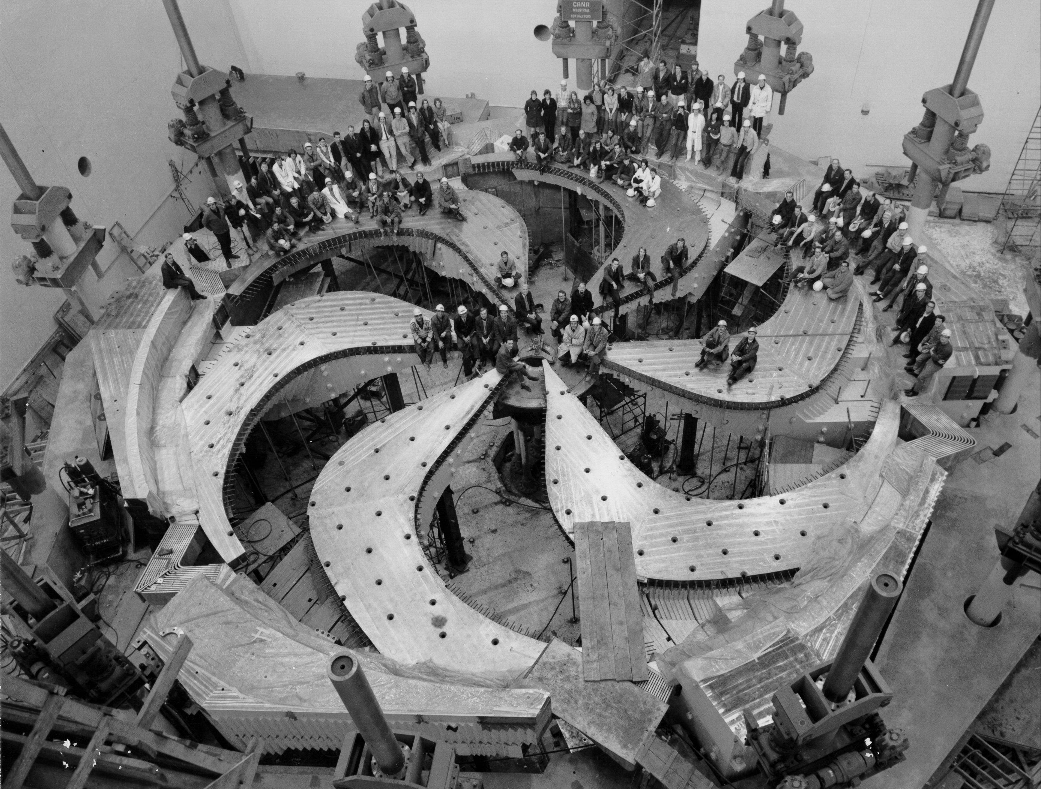

## Research Interest

Design of CMOS Integrated Circuit 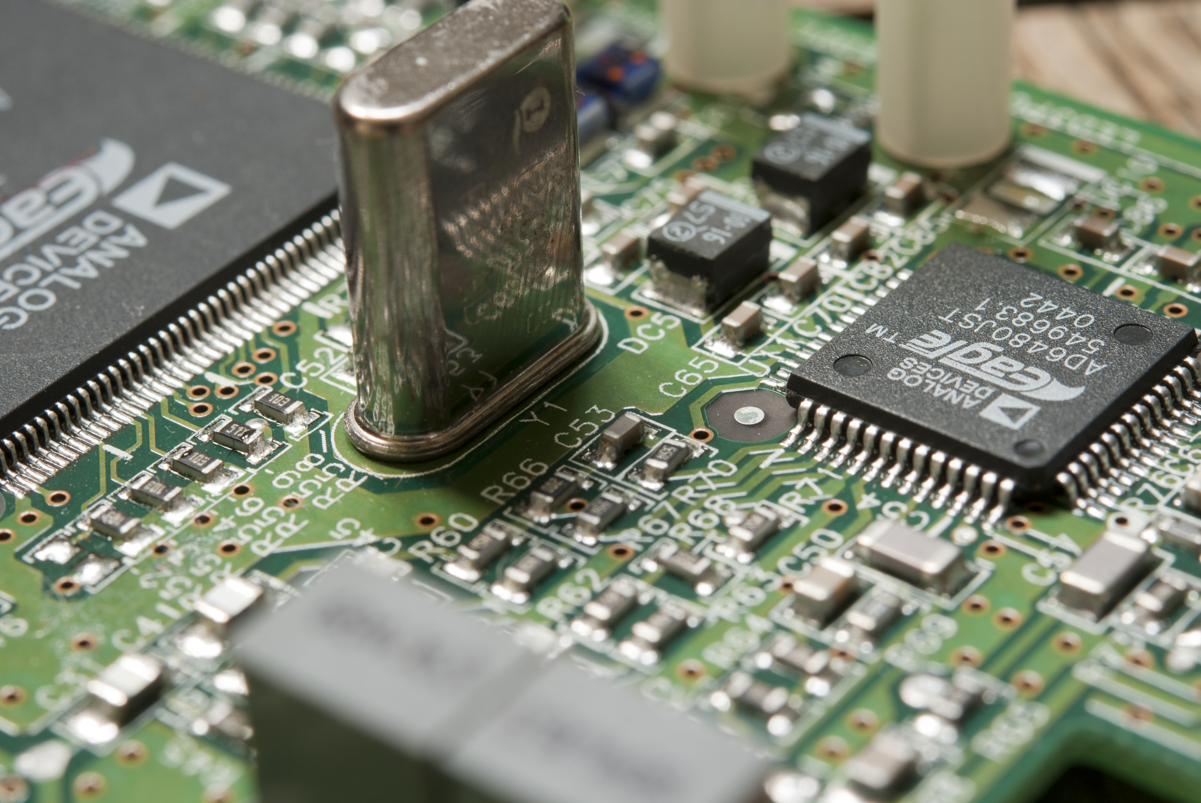

## Hobbies

* Travel :airplane:
* [x]Disneyland
* [x]Seattle
* [ ]Cuba
* [ ]Hawaii  
* Board skiing :surfer: 
* Pay the Piano :musical_keyboard: 
* Enjoy delicous food :ramen: 